**DSM Lab Report**

**Name:** Anirudh Kaushik

**Roll No:** 2020111015

**Group Number:** 5

**Objective:**

1. To make an LED blink using Arduino
2. To turn on and turn off an LED using Arduino
3. To get familiarized with Arduino and Tinkercad simulation software

**Experiment setup/ procedure:**

**Materials required:**

1. 1xLED
2. 1xArduino uno
3. 5xconnecting wires
4. 1xBreadBoard
5. 1x1kΩ resistor

**Procedure:**

1. Take the BreadBoard and connect an LED across row b holes 14(Cathode) and 15(Anode).
2. Connect a wire(red) in row a hole 14 to the second last row marked (-) in the hole in the same column.
3. Connect a wire(red) in the adjacent hole in the second last row marked (-) to the port marked GND(ground) in the Arduino.
4. Connect the 1kΩ resistor in row c in holes 19 to 23.
5. Connect a wire(green) in row d from holes 15 to 19 such that the wire in the hole just above the resistor.
6. Connect a wire(black) in row d hole 23 (right above the resistor) to the hole in the corresponding column in the second row from the top marked(+).
7. Connect a wire(black) in the column corresponding to hole 25 in the second row from the top marked(+) and connect its other end to the Arduino port marked 13.
8. The connections are now complete and the LED should blink when the code stated below is entered.

**Code:**

void setup()

{

pinMode(13, OUTPUT);

}

#define ON HIGH //to substitute ON instead of HIGH

#define OFF LOW //to substitute OFF instead of LOW

void loop()

{

digitalWrite(13, ON); //switches the LED ON

delay(1000); // Wait for 1000 millisecond(s)

digitalWrite(13, OFF); // switches the LED OFF

delay(1000); // Wait for 1000 millisecond(s)

}

**Conclusion:**

1. Successfully learnt how to use basic functions of Tinkercad simulation software.
2. Successfully learnt how to use basic functions of an Arduino.
3. Successfully made an LED blink with a delay of 1000 microseconds by inputting required code in Arduino.
4. Familiarized ourself with the connections in a BreadBoard.

**Tinkercad Link with Circuit:**

<https://www.tinkercad.com/things/anj8QAJP52u-swanky-snicket-luulia/editel?sharecode=hpATYZ_owYs6cyRfPvwWj47YV7xzaNFzFDo09Wnxh9k>

**Circuit Diagram:**

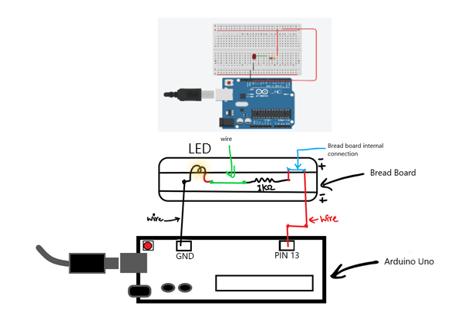

MADE USING PAINT 3d